Description of Product
Product Description:
This product are lead based compound stabilizer containing light Lead based compound, antioxidant, internal and external lubricants, which is applicable for U-PVC pipe extrusion. It is irregular flake or granule and dust-free. It contains proper composite antioxidant and macro molecule auxiliaries, which can obviously improve the outdoor using performance and surface property of PVC pipe and pipe fitting.
Product performance:
This series product has good thermal stability and processing performance, reasonable formulation. It has excellent internal and external lubricating balance; do not need any more lubricant. It is especially suitable for pressure pipes, has wide compatibility to the different feed rate and different quality padding.

Pictures of Product
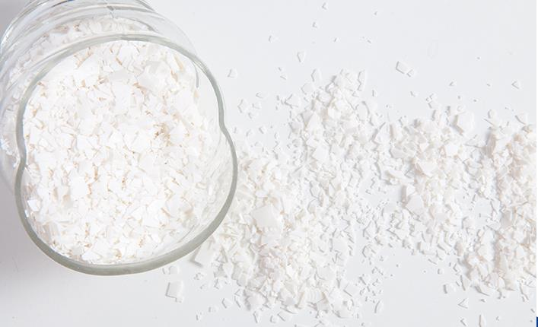
Application
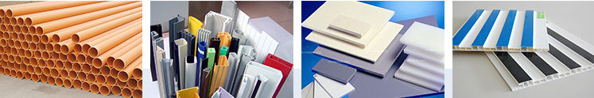
Piping, hard transparent plate. Film and sheeting, Photograph records. PVC fibers, plastics blowing, electric insulation materials:
- Construction material:Piping, sheeting,windows and door. 4.Furniture:Decorate material
- Packing material 5.Other: Car material, medical appliance
- Electronic material: Cable, wire, tape, bolt 6.Transportation and storage

Workshop And Lab
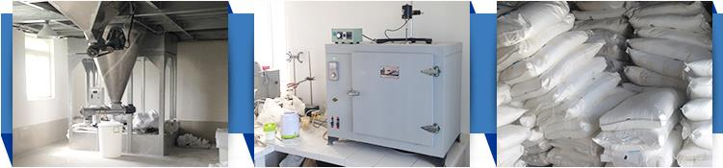
Our Company
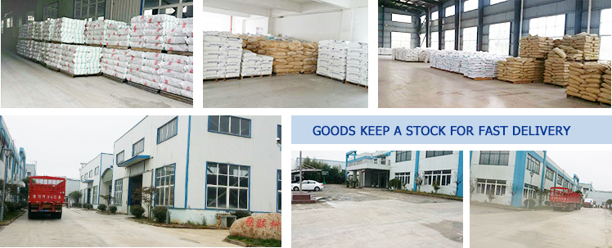
Our Team & Services
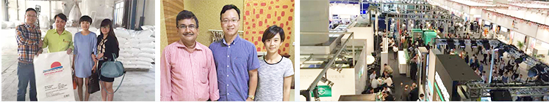
1. Provide personalized customer's services;
2. Embrace flexibility and professionalism;
3. No lowest price but always value of money;
4. Treat workers and other suppliers as respectful partners.
In the past more than10 years, with high quality products and outstanding customer services.
Jubang has gained a global sales network, covering Europe, USA, Southeast Asia, India, Africa and South America, etc.

FAQ:
1: What is your packing?
A: 25kg/bag or as customers' requirement.
2: What is the payment method?
A: T/T
3: What is the minimum quantity
A: 17 Tons
4: What is the means of transport
A: By ocean shipping, from Shanghai port.
5: How can I get samples?
A: We are honored to offer you PE wax samples free. But you have to pay for the freight.
6: How does your factory do regarding quality control?
A: Quality is priority. We always attach great importance to quality control from the very begining to the very end. Our factory has gained SGS authentication. Every batch has its own test report.

