Product description
XIZHOU PE Wax is actually a saturated fatty alcohol acid ester, it is white small granule or free flow powder and is nontoxic and odourless, it can not be dissolved in water, but dissolves in tributyl phosphate(TBP) and chloroform, it has the excellent dispersion and transparency, it can be used to produce all kinds of PVC products as a lubricant.
Typical physical properties:
Item | Index
Appearance | white granule or powder
Melting point | 100-105℃
Acid value | ≤0.5mgkoh/g
Molecular weight | 2000-4000
Bulk density | 0.86-0.93g/cm3
Product’s advantages:
- Improve the melt flow ability;
- Without any effects on transparency;
- Provide lubricating property without lowering melt-strength;
- Promote fusion of PVC blend;
- Endow the gloss surface to PVC finished products.
Picture of Product:
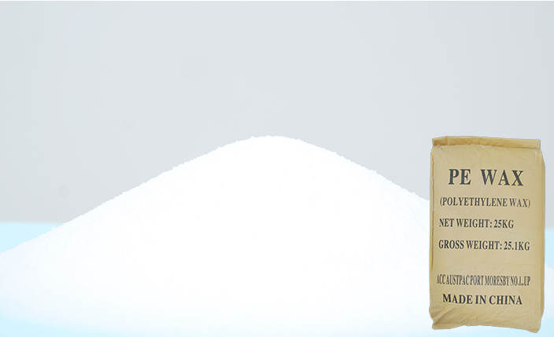

Applications:
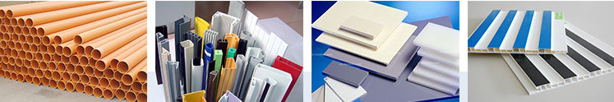
PE wax is recommended for all kinds of PVC applications such as PVC window profile, PVC door, PVC fencing, PVC clear film, PVC clear sheet, PVC bottle, PVC foam board etc. as lubricant.
Recommended using dosage: 0.3-1.2kg per 100kg PVC resin.

Production Line of Product:
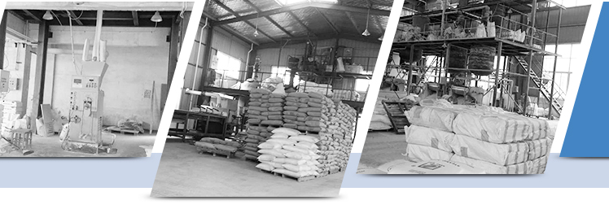
Packaging and Shipping of Product:
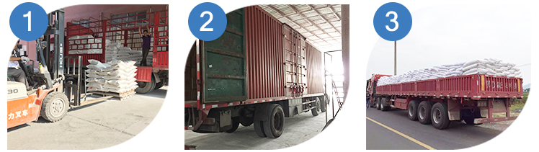
Storage method: Should be stored in cool and dry surroundings with shelf life of two years,it can be used if qualified by inspection after shelf life.
Packing: Composite plastic woven bag, net weight 25kg
Our Company:
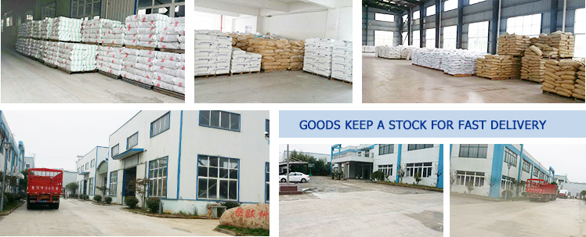
Our Team&Services:
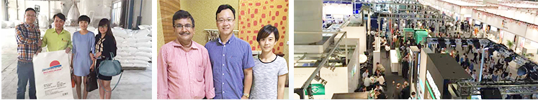
1. Provide personalized customer's services;
2. Embrace flexibility and professionalism;
3. No lowest price but always value of money;
4. Treat workers and other suppliers as respectful partners.
In the past more than10 years, with high quality products and outstanding customer services.
Jubang has gained a global sales network, covering Europe, USA, Southeast Asia, India, Africa and South America, etc.
FAQ:
1: What is your packing?
A: 25kg/bag or as customers' requirement.
2: What is the payment method?
A: T/T
3: What is the minimum quantity
A: 17 Tons
4: What is the means of transport
A: By ocean shipping, from Shanghai port.
5: How can I get samples?
A: We are honored to offer you PE wax samples free. But you have to pay for the freight.
6: How does your factory do regarding quality control?
A: Quality is priority. We always attach great importance to quality control from the very begining to the very end. Our factory has gained SGS authentication. Every batch has its own test report.

